|  |  |  |
| --- | --- | --- |
| **S. No.** | **Contents** | **Contact hours** |
|  | **Introduction to Data Science:** Latest and greatest in data science | 2 |
|  | **Data Analysis Foundation:** Types of data (data matrix, numeric, categorical datasets), data preparation: data cleaning, data reduction and transformation | 6 |
|  | **Exploratory Data Analysis and Visualization:** Univariate and bivariate analysis, data visualization (scatterplots, bar and column charts, line charts, pie charts etc.) | 10 |
|  | **Statistical Analysis:** Confidence Intervals,Hypothesis Testing, p-values, Bias and Variance trade-off | 6 |
|  | **Machine Learning:** introduction to supervised and unsupervised methods, model training, overfitting and underfitting, bias and variance, introduction to supervised methods: regression and classification (Linear regression, logistic, decision trees, SVM), Clustering, K-means, PCA | 11 |
|  | **Deep learning and Big Data:** Gradient Descent**,** Neural nets, Convolutional Neural Networks, Big Data technologies (MapReduce, HDFS) | 7 |
| **Total** | | **42** |

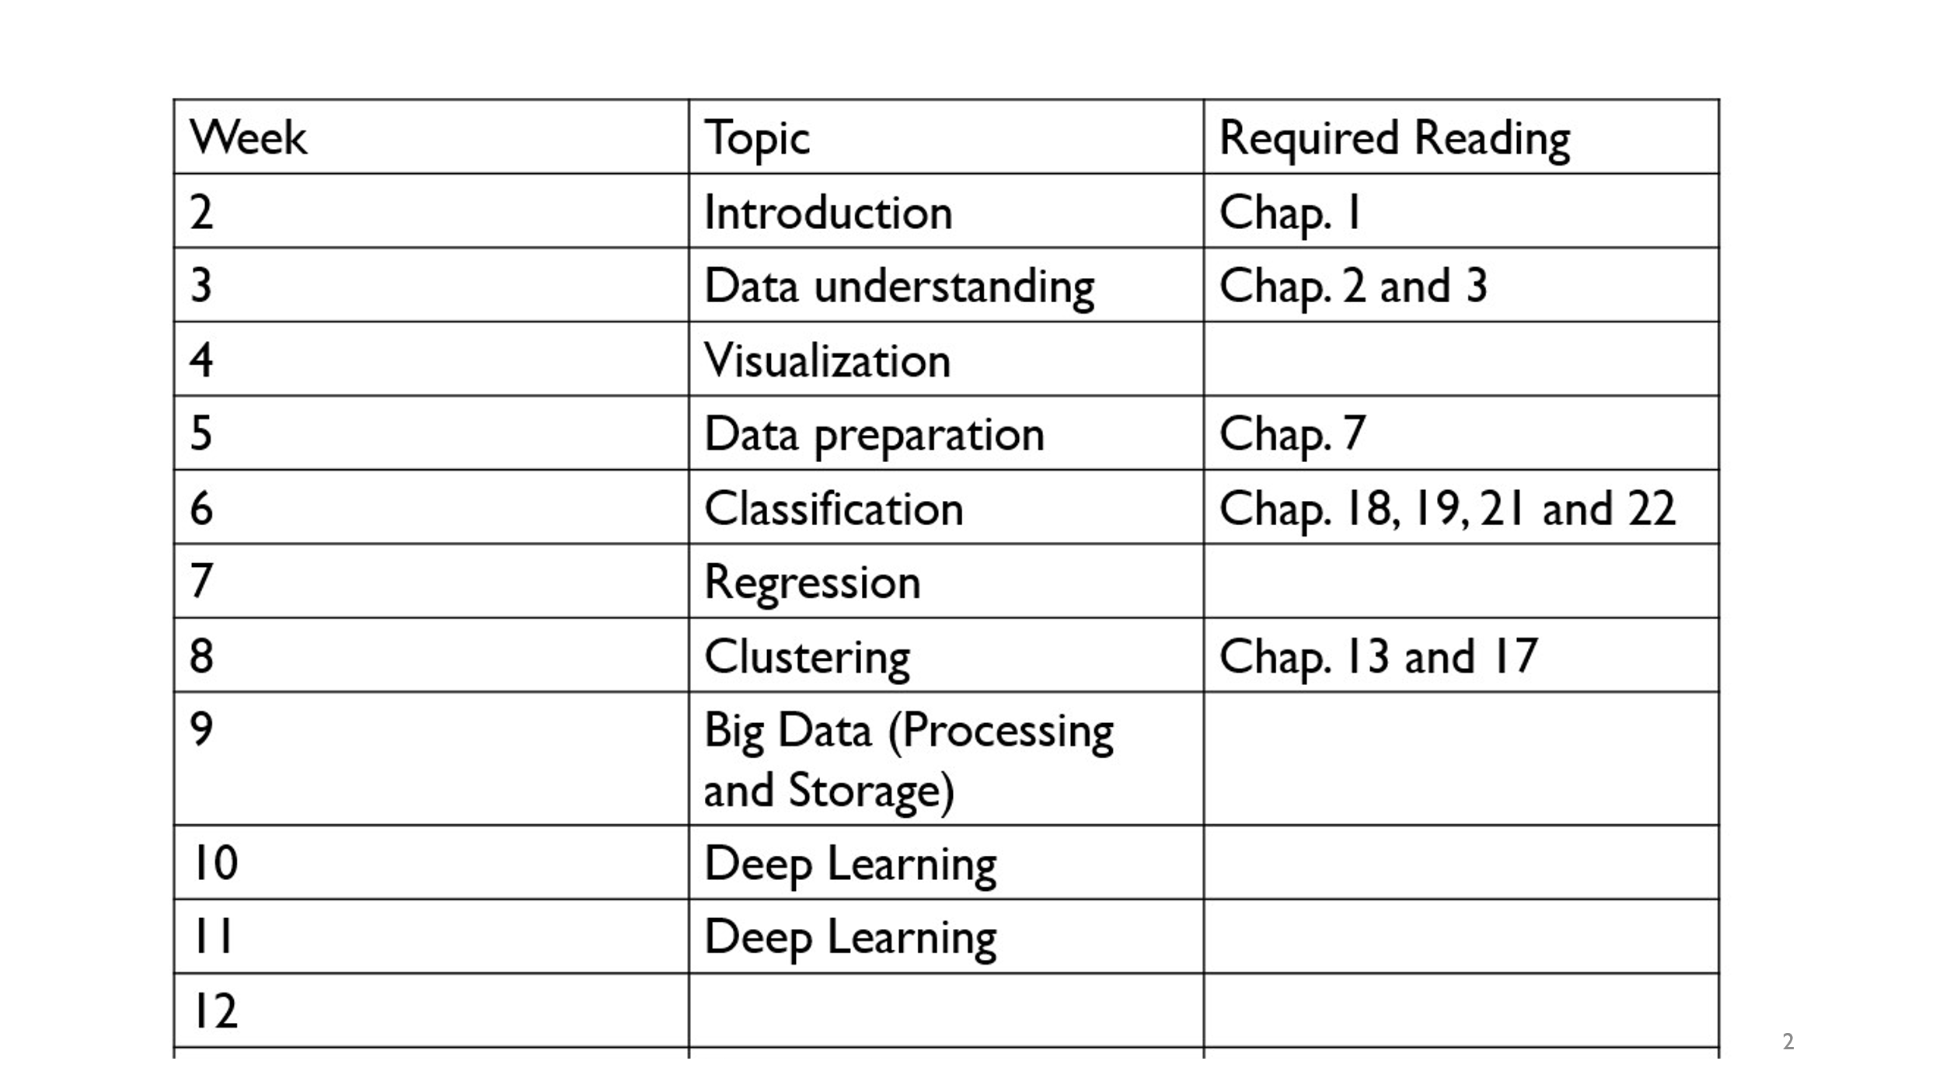

You can read these chapter online from below link:

Book Info: <http://dataminingbook.info/>

* Mohammed J. Zaki, Wagner Meira, Jr., Data Mining and Machine Learning: Fundamental Concepts and Algorithms, 2nd Edition, Cambridge University Press, March 2020. ISBN: 978-1108473989.